**BUSINESS ANALYTICS**

**Top of Form**

**Introduction**

Business analytics is the process of analysing data to improve business decisions. It involves using statistical and quantitative methods to identify patterns, trends, and root causes in historical business data. The goal is to use these insights to make data-driven decisions, improve processes, and inform strategic planning. Business analytics can help

companies: Solve business problems, to monitor business fundamentals, identify new growth opportunities, Better serve their customers, and Anticipate business problems and forecast trends.

Business analytics uses data exploration, data visualization, integrated dashboards, and more to provide users with access to actionable data and business insights.

Specifically, business analytics refers to:

* Taking in and processing historical business data
* Analysing that data to identify trends, patterns, and root causes
* Making data-driven business decisions based on those insights

In other words, data analytics is more of a general description of the modern analytics process. Business analytics implies a narrower focus and has functionally become more prevalent and more important for organizations around the globe as the overall volume of data has increased.

Using cloud analytics tools, organizations can consolidate data from different departments—sales, marketing, HR, and finance

for a unified view that shows how one department’s numbers can influence the others. Further, tools, such as visualization, predictive insights, and scenario modelling

deliver all kinds of unique insights across an entire organization.

**Popular Business Analytics Tools**

|  |  |
| --- | --- |
| **1. Microsoft Power BI**   * Purpose: Data visualization and reporting. * Features: Easy-to-use dashboards, real-time insights, and integration with Microsoft apps   **2. Tableau**   * Purpose: Data visualization. * Features: Drag-and-drop interface, advanced charting, and integration with multiple data sources.   **3. Google Data Studio**   * Purpose: Free tool for data visualization. * Features: Real-time collaboration integrates with Google Analytics, Ads, and other platforms**.** | **4. Excel**   * Purpose: Spreadsheet analysis and modelling. * Features: Data storage, pivot tables, charts, and advanced formula.   **5. SAS (Statistical Analysis System)**   * Purpose: Advanced analytics and data mining. * Features: Statistical modelling, forecasting, and machine learning capabilities.   **6. R and Python**   * Purpose: Programming for statistical analysis and machine learning. * Features: Highly customizable, libraries for advanced analytics (e.g., pandas, ggplot2). |

**Software Development Life cycle**

The Software Development Life Cycle (SDLC) is a structured framework that outlines the process of developing software from start to finish.

**1.Planning:**

The planning phase typically includes tasks like cost-benefit analysis, scheduling, resource estimation, and allocation. The development team collects requirements from several stakeholders such as customers, internal and external experts, and managers to create a software requirement specification document.

2. **Design**:

In the design phase, software engineers analyse requirements and identify the best solutions to create the software. For example, they may consider integrating pre-existing modules, make technology choices, and identify development tools.

3. **implement**:

In the implementation phase, the development team codes the product. They analyse the requirements to identify smaller coding tasks they can do daily to achieve the result.

4**. Test:**

The development team combines automation and manual testing to check the software for bugs. Quality analysis includes testing the software for errors and checking if it meets customer requirements.

5. **Deploy:** When teams develop software, they code and test on a different copy of the software than the one that the users have access to. The software that customers use is called *production*, while other

copies are said to be in the build environment or testing environment.

6. **Maintain:**

In the maintenance phase, among other tasks, the team fixes bugs, resolves customer issues, and manages software changes. In addition, the team monitors overall system performance, security, and user experience to identify new ways to improve the existing software.

**SDLC Life Cycle**

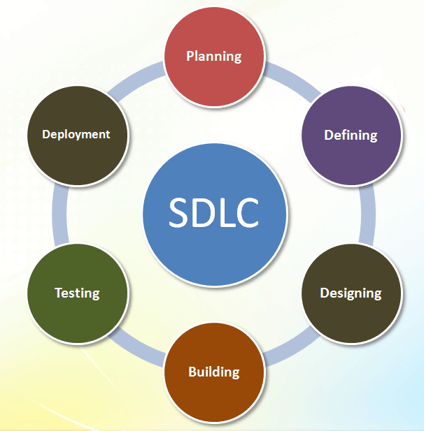

**common SDLC Models:**

1. Waterfall: Sequential and linear; best for projects with clear, unchanging requirements.
2. Agile: Iterative and flexible; focuses on collaboration and incremental deliveries.
3. Spiral: Combines iterative development with risk analysis.
4. V-Model: Emphasizes validation and verification at each stage.

**Agile sprint**

**Introduction:**

Agile sprint is a short, time-boxed period when a team works to complete a set amount of work within an agile methodology. Sprints are a fundamental concept in agile methodologies, such as Scrum, and are used to break down large projects into smaller, more manageable pieces.

The purpose of a sprint is to deliver a potentially releasable product increment that meets the agreed-upon Definition of Done **(**DoD)—a shared standard that ensures quality and completeness.

Each sprint is designed to produce tangible and valuable progress toward the product’s overarching goals by focusing on incremental improvements and continuous feedback. Sprints are a core component of the Agile and Scrum frameworks, enabling teams to work in a disciplined yet flexible manner, adapt to changing priorities, and enhance overall productivity through regular inspections and adaptations.

Here are some characteristics of agile sprints:

* Short: Sprints are usually short, lasting one to two weeks or less than a month.
* Iterative: Sprints encourage iterative development and continuous improvement.
* Measurable: Sprint goals are always measurable.
* Collaborative: Sprints encourage team members to work together and collaborate frequently.
* Stand-ups: Daily Scrum meetings, also known as stand-up meetings, ensure sprints are running on schedule

**Stages of Agile Sprint**

1.**Sprint Review**

* + Held at the end of the sprint to showcase completed work to stakeholders.

Feedback is Sprint Planning.

The team collaborates to define the sprint goal and selects items from the product backlog to include in the sprint backlog.

* + Tasks are broken down into smaller, manageable chunks.

1. **Daily Stand-ups**
   * Brief daily meetings (15 minutes) to ensure team members are aligned.
   * Team members share:
     + What they accomplished yesterday.
     + What they will do today.
     + Any blockers they’re facing.
2. **Execution**
   * Team members work collaboratively on tasks, keeping progress visible through tools like a Kanban board or burndown chart.
   * gathered to inform future sprints.

**Sprint Retrospective**

1. The team reflects on the sprint to identify what went well, what didn’t, and what can be improved.

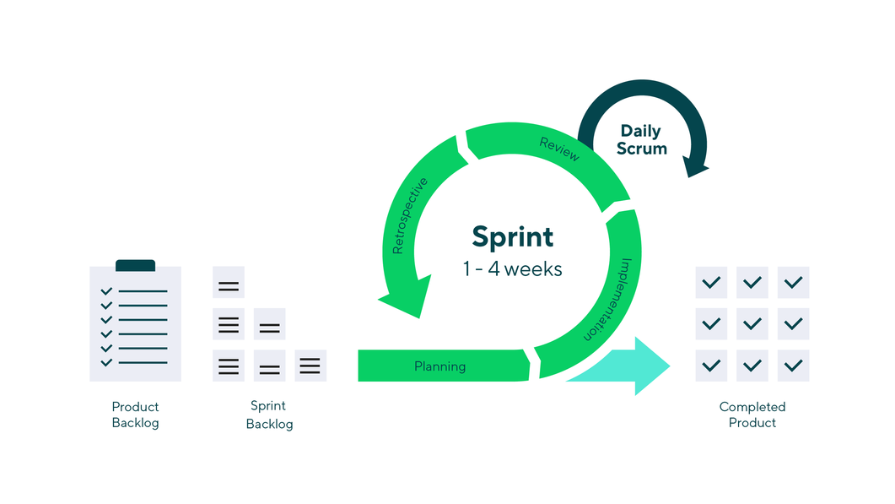

**Agile sprint cycle**

**key Benefits**

* Flexibility: Adapt to changing requirements.
* Transparency: Frequent reviews and retrospectives promote openness
* Customer Focus: Delivering usable increments ensures alignment with user needs.

“**Virtual Shopping Analysis: A Data-Driven Study of Lavie Bags**”

**1.Introduction**

In the digital age, understanding how a brand resonates with its audience is crucial for success. For **Lavie Bags**, a leading fashion brand known for its stylish handbags, staying ahead of market trends and customer preferences requires a data-driven approach. Online brand analytics offers invaluable insights, helping businesses like Lavie Bags optimize their digital presence, refine marketing strategies, and enhance customer engagement.

The project focuses on analyzing the online brand presence of Lavie Bags, a prominent fashion accessory brand known for its trendy handbags. The study aims to explore how Lavie Bags uses online data analytics to enhance its brand perception, customer engagement, and sales performance. By utilizing data from various digital platforms such as e-commerce, and reviews

**2. Objectives**

* To analyse the online brand sentiment surrounding Lavie Bags using data from social media platforms and customer reviews.
* To assess the effectiveness of Lavie Bags’ online marketing campaigns and content strategies.
* To understand customer behaviour, preferences, and trends through e-commerce analytics.
* To evaluate Lavie Bags' competitive positioning in the digital marketplace.
* To suggest strategies for enhancing the online brand experience based on data insights**.**

**3.Research** The research will be conducted using a combination of the following methods:

* **Social Media Analysis**: Data will be collected from platforms like Instagram, Facebook, and Twitter to understand customer engagement, sentiment, and brand awareness.
* **E-Commerce and Website Analytics**: Data from Lavie Bags' official website and e-commerce platforms like Amazon, Flipkart, and Myntra will be analysed to track consumer browsing and purchasing behaviour. Key metrics such as traffic, bounce rates, and conversion rates will be assessed.
* **Customer Reviews and Feedback**: Online customer reviews from e-commerce platforms and dedicated review sites will be examined to identify patterns in customer satisfaction and areas for improvement.
* **Competitor Benchmarking**: A comparative analysis of Lavie Bags with its competitors in the market will be conducted using online analytics tools to assess its competitive advantage.

**4.Collecting Data**

• **Social Media Engagement Metrics:** Likes, shares, comments, and user-generated content related to Lavie Bags.

• **Customer Reviews:** Positive and negative reviews on popular platforms such as Amazon, Myntra, and Flipkart.

• **Website Analytics:** Traffic data, bounce rate, time spent on the site, and conversion rate.

• **Search Trends:** Google Trends data for keywords related to Lavie Bags.

**5.Data Processing and Cleaning**

* Clean and preprocess the data to remove any irrelevant or duplicate entries.
* Normalize data to ensure consistency across various platforms (e.g., product names, categories, ratings).

**6.Data Analysis Techniques**

* **Sentiment Analysis**: To understand the tone of consumer feedback (positive, negative, or neutral).
* **Trend Analysis:** Identifying patterns in customer preferences and the popularity of specific products.
* **Engagement Analysis**: Analysing the interaction levels with social media content and the effectiveness of paid ads.
* **Conversion Rate Optimization (CRO):** Assessing the effectiveness of Lavie Bags' e-commerce platform in converting visitors into buyers.
* **Competitive Positioning**: Benchmarking Lavie Bags against its competitors based on online metrics.

**7.tools Used**

* **Excel/Google Sheets**: For basic data processing and visualization.
* **Power BI/Tableau**: For creating dashboards and advanced visualizations.
* **R/Python**: For statistical analysis, predictive modelling, and sentiment analysis.

**8.Key Performance Indicators**

To assess the success of Lavie Bags' online sales efforts, the following KPIs will be measured:

* **Conversion Rate**: The percentage of website visitors who make a purchase.
* **Average Order Value:** The average amount spent per order.
* **Customer Retention Rate**: The percentage of repeat customers over a defined period.
* **Top Selling Products**: Identify which products generate the most revenue.
* **Customer Lifetime Value** : The total revenue generated from a customer over their lifetime.

**9.Product Performance Analysis**

* Top Products: Highest revenue and sales.
* Categories: Popular product types.
* Promotions: Impact of discounts.
* Shoppers: Frequent and high-value customers.
* Sentiment: Customer feedback on products, shipping, and service.

### **10. Conclusion**

In the competitive world of e-commerce, data analytics is a powerful tool for improving decision-making and driving growth. For Lavie Bags, understanding online shopping behaviour is crucial for staying ahead of the competition. This project provides actionable insights that will help Lavie Bags optimize marketing strategies, improve customer satisfaction, and increase sales. By leveraging business analytics, Lavie Bags can continue to grow its online presence and strengthen its position in the market.

**Sprint: Data-Driven Innovation for Virtual Shopping of Lavie Bags**

**Sprints 1-2: Discovery & Planning**

* Define project requirements.
* Creating user stories and high-level architecture.
* Outcomes: Requirements document, initial backlog, and wireframes.

**Sprints 3-4: Infrastructure Setup**

* Set up cloud hosting, databases, and analytics tools.
* Build foundational backend services and prototype shopping interface.
* Outcomes: Backend setup, database integration, and prototype demo.

**Sprints 5-6: Core Features Development**

* Develop product browsing, shopping cart, and payment gateway.
* Set up basic analytics for tracking user behaviour.
* Outcomes: Functional shopping flow and analytics tracking.

**Sprints 7-8: Advanced Analytics**

* Integrate tools like Power BI for dashboards.
* A/B testing for UI/UX optimization.
* Outcomes: Real-time analytics dashboards and test reports.

**Sprints 9-10: Enhanced Virtual Experience**

* Implement virtual try-on (AR/3D visualization).
* Add personalized recommendations using machine learning.
* Outcomes: Try-on module and recommendation engine prototype.

**Sprints 11-12: Marketing Tools**

* Develop features for promotions and campaigns (e.g., coupons, flash sales).
* Analyse ROI from marketing efforts.
* Outcomes: Campaign tools and marketing performance reports.

**Sprints 13-14: Security and Compliance**

* Implement data encryption and ensure compliance (e.g., GDPR).
* Perform security audits and penetration testing.
* Outcomes: Secure system and compliance certification.

**Sprints 15-16: Final Testing and Launch**

* Conduct end-to-end testing and refine features.
* Deploy platform and train stakeholders.
* Outcomes: Live platform, documentation, and sprint retrospective.

**Budget Table for Virtual Shopping Analysis on Lavie Bags**

|  |  |  |  |
| --- | --- | --- | --- |
| **Category** | **Details** | **Cost per Month (₹)** | **Total Cost (₹)** |
| Team Salaries | 5 Developers @ ₹1,00,000/month | ₹5,00,000 | ₹40,00,000 |
| Tools & Software | Analytics tools, software licenses | ₹50,000 | ₹4,00,000 |
| Infrastructure | Cloud services, servers, storage | ₹30,000 | ₹2,40,000 |
| Research & Data | Data acquisition, user surveys | ₹25,000 | ₹2,00,000 |
| Customer Insights | Focus groups, sentiment analysis | ₹20,000 | ₹1,60,000 |
| Training | Upskilling team on analytics tools | ₹15,000 | ₹1,20,000 |
| Marketing & Outreach | Promoting virtual shopping platform | ₹20,000 | ₹1,60,000 |
| Miscellaneous | Contingency for unforeseen expenses | ₹10,000 | ₹80,000 |

|Total Budget ₹51,60,000